The Scotch Whisky Association
Job Application Form

The Scotch Whisky Association is a prestigious organisation that works for and on behalf of our members to protect and secure a sustainable future for the Scotch Whisky Industry. We can offer the opportunity to join a thriving industry with colleagues who have a wealth of experience and knowledge in our industry.

Application for | Legal Counsel
Where did you see the job advertised?

Personal Information (this information will not be seen by shortlisting panel)
Title (optional):
Full Name:
Address:
Postcode:
Email:
Telephone:
Do you consider yourself to have a disability? | [Yes/No]
If yes, please contact our HR team at hr@swa.org.uk to discuss any adjustments you may require during the recruitment process
Please return this completed application form to our HR team at hr@swa.org.uk by 29 April 2024.
This page is intentionally blank

Section 1 – Education and Training

Please provide details of education and any relevant training

Please provide details of any relevant qualifications (particularly with reference to the person specification in the job description if appropriate)

Section 2 – Employment history

Please provide details of your current and previous roles

From (date) | To  (date) | Job title | Employer | Brief summary of responsibilities and achievements | Reason for leaving
Current (or most recent if not currently employed) role
Previous roles

Section 3 – Person Specification
Experience and Knowledge
Please provide details of how your experience and knowledge match the requirements set out in the job description

Skills and Personal Qualities
Please provide details of how your skills and personal qualities match the requirements set out in the job description

Section 4 – Any other supporting information

Please provide any other information you wish in support of your application (optional)

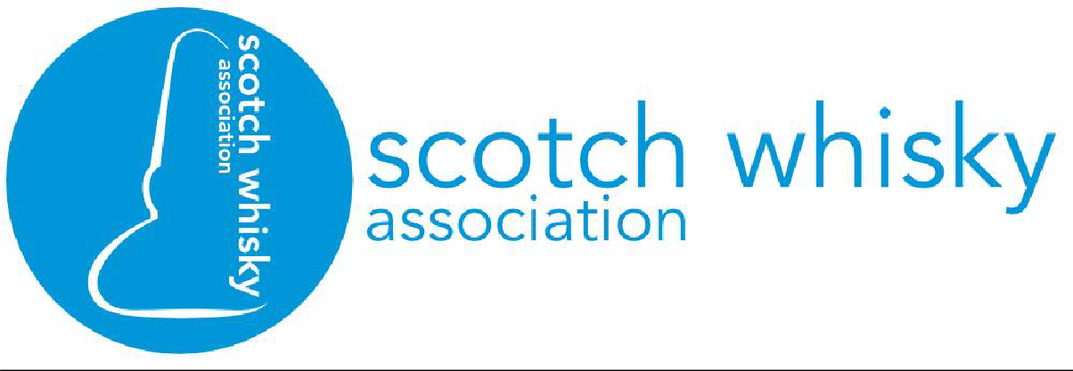
Full Job Description: Legal Counsel

Date Created | 16/4/24
Department | Legal Affairs
Job Title | Legal Counsel
Working hours | Full time (hybrid working) but equivalent of 4 days may be considered
Reporting to | Director of Legal Affairs
Salary | From £48,000 for NQ and otherwise dependent on experience.
Start Date | From July
Overview
Legal Counsel is a member of the Legal Affairs team, whose primary function is to safeguard the Scotch Whisky category. Within that function, the team requires to:
- secure and maintain recognition of Scotch Whisky as a description reserved only for whisky produced in Scotland;
- take action to stop the sale of products being passed off as Scotch Whisky;
- take action to prevent the registration of trade marks which falsely evoke Scotch Whisky;
- advocate for greater awareness of and effective action on illicit trade; and
- ensure a fit for purpose domestic and overseas regulatory framework for the protection of Scotch Whisky which supports the long-term interests of members.

Main Responsibilities
Legal Counsel must be prepared to work under close supervision initially and thereafter to consult where appropriate. After a three month probationary period, the applicant will be expected to assume responsibility for the conduct of particular cases (investigations, litigation and trade marks) and areas of work. Their work will be principally focused on Asia-Pacific and the Americas.

Legal Counsel will require to become familiar with:

-the structure and activities of member companies, and their brands, and with companies and brands in the whisky trade world-wide;

-the production process of Scotch Whisky and have a working knowledge of the scientific methods of analysis used to determine imitation products; and

-the applicable laws and procedures and market developments in relevant countries.

Essential responsibilities will include investigations and litigation, trade marks and other functions, as described below.

Essential Tasks
Investigations and litigation

This will include (but is not limited to):

- evaluating and investigating misleadingly labelled products and assessing the action required;
- arranging for the analyses of suspect products;
- obtaining and submitting evidence in appropriate form for legal proceedings worldwide;
- instructing and directing lawyers in relevant jurisdictions in the conduct of the cases, including detailed preparation and consideration of all written pleadings, in the areas of passing off, unfair competition and breach of geographical indication protection;
- negotiating, drafting and revising settlement agreements directly and through local lawyers; and
- monitoring all fees and costs.

Trade Marks

Legal Counsel assists with the review of trade mark applications to determine whether they are deceptive and/or damaging to Scotch Whisky, and decide upon appropriate action. This may include the negotiation of undertakings or restrictions on use or, where necessary, arranging for opposition to the application and any further procedure. At least initially, this will make up the majority of the workload.

Other functions include:

- providing guidance to member companies on various matters;
- liaising with enforcement authorities throughout the world on the protection of the Scotch Whisky geographical indication;
- preparation of briefs and discussions with officials relating to relevant legislation;
- addressing general legal enquiries from members of the SWA, other companies and the public; and
- assisting other teams with legal matters as required.

What we offer
The Scotch Whisky Association is a prestigious organization which works on behalf of our members to protect and secure a sustainable future for the Scotch Whisky industry. We can offer the right candidate the opportunity to join a thriving industry with colleagues who have a wealth of experience and knowledge.

Our People and Culture Plan ensure employees are at the forefront of our minds. Some of our benefits are:
- We review salaries regularly, working with external consultants to ensure our people are rewarded fairly. The salary on offer for this role starts from £48,000 for newly qualified, and otherwise dependent on experience.
- We offer employer pension contributions matching employee contributions plus 3%, up to a maximum of 15%.
- We have several engagement days throughout the year as well as activity days to take us away from the office to collaborate, communicate and strengthen our team.
- Our people policies reflect our investment in both physical and mental wellbeing. We provide a cycle to work scheme, BUPA healthcare (after 2 years’ service), life assurance and group income protection packages alongside retirement and financial planning training.
- We offer personal and professional career development opportunities, with a focus on ensuring our people are equipped with the tools they need to do their job and progress their career.
- Our flexitime and hybrid working policies support our people to find the best individual balance between work and life commitments.

Person Specification
Experience & Knowledge
Essential |  | Desirable
The applicant must be a solicitor or an advocate/barrister qualified to practice in either Scotland or England & Wales, with up to 3 years PQE. |  | Civil litigation experience.  A strong interest in intellectual property law.
Skills
Essential |  | Desirable
Excellent negotiation and communication skills
Attention to detail
Ability to work in a collaborative manner
Capable of creative thought
Willing to undertake thorough and detailed preparatory work
High standard of literacy and accuracy

