The Scotch Whisky Association
Job Application Form

The Scotch Whisky Association is a prestigious organisation that works for and on behalf of our members to protect and secure a sustainable future for the Scotch Whisky Industry. We can offer the opportunity to join a thriving industry with colleagues who have a wealth of experience and knowledge in our industry.

Application for | Regulatory Affairs Manager

Personal Information (this information will not be seen by shortlisting panel)

Title (optional):
Full Name:
Address:
Postcode:
Email:
Telephone:
Do you consider yourself to have a disability? | [Yes/No]
If yes, please contact our HR team at hr@swa.org.uk to discuss any adjustments you may require during the recruitment process

Please return this completed application form to our HR team at hr@swa.org.uk by 29 April 2024.
This page is intentionally blank

Section 1 – Education and Training

Please provide details of education and any relevant training

Please provide details of any relevant qualifications (particularly with reference to the person specification in the job description if appropriate)

Section 2 – Employment history

Please provide details of your current and previous roles

From (date) | To  (date) | Job title | Employer | Brief summary of responsibilities and achievements | Reason for leaving
Current (or most recent if not currently employed) role
Previous roles

Section 3 – Person Specification
Experience and Knowledge
Please provide details of how your experience and knowledge match the requirements set out in the job description

Skills and Personal Qualities
Please provide details of how your skills and personal qualities match the requirements set out in the job description

Section 4 – Any other supporting information

Please provide any other information you wish in support of your application (optional)

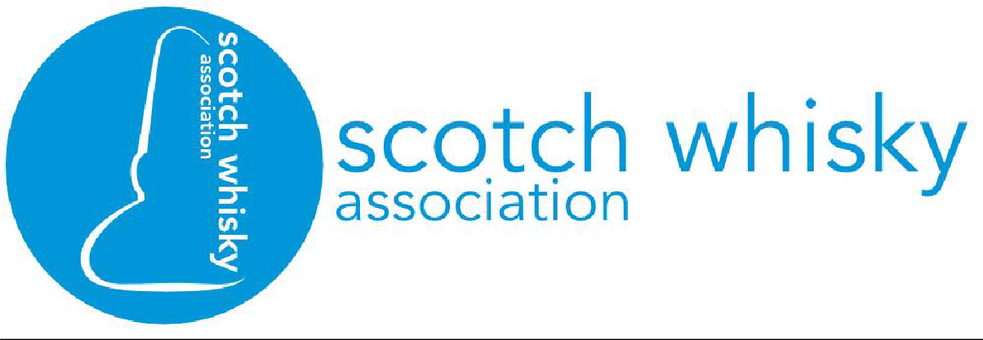
Full Job Description: Regulatory Affairs Manager

Date Created | 03/04/2024
Department | Industry Sustainability
Job Title | Regulatory Affairs Manager
Working hours | 35 per week (flexible requests considered)
Reporting to | Deputy Director, Industry Sustainability Team
Salary | c. £45,000 – £53,000
Start Date | TBC
Overview
The production of Scotch Whisky is highly regulated. Compliance is essential and cuts across all the industry’s operations including customs and excise, health and safety, environment and food safety.
This role will play an important role supporting sector compliance and providing a voice to influence and inform policy development. This will include representation on behalf of SWA and members at external meetings and being seen as the go-to industry expert; influencing and lobbying government and regulatory bodies where needed; monitoring legislation and other regulatory issues.
You will lead on the initiation and formulation of industry policy in key areas of regulation for Scotch Whisky production including customs and excise and control of major accidents and hazards (COMAH) in consultation with member companies. Customs and Excise regulations and controls apply from the moment cereals are first processed in our distilleries through to the export of bottled Scotch Whisky. This is an important, and at times complex, area. Topics include the holding and movement of excise goods, customs controls and processes, verification and alcohol fraud.
The role will provide the opportunity to lead on these two important topics within our iconic industry, and supporting on others. You will work with senior managers in the Industry Sustainability team, reporting to the Deputy Director. You will be confident in working independently but will have the wider support of the team including its senior managers to provide guidance as needed.
Your role will also include working with senior colleagues in our member businesses and engagement with key regulators, notably HM Revenue & Customs (HMRC), which will be the primary focus, and the Health & Safety Executive (HSE).

Main Responsibilities
- Monitor and assess regulatory and other changes to understand impact or outcomes for member companies.
- Ensure clear analysis of complex areas of regulation to support member engagement, to provide insights for members to support their implementation and compliance with HMRC and health and safety policies and regulations.

Essential Tasks
- Lead industry engagement with key regulators (notably HMRC and HSE) and other stakeholders, such as other trade association, where appropriate
- Preparation of consultation responses and calls for evidence
- Research and develop accurate, persuasive briefings or other materials for internal and external use
- Develop targeted engagement plans to advance industry positions with regulators
- Administration of relevant working groups and committees (includes setting agendas, records of meetings, arranging meetings and follow-up actions)
- Organising events (including on-line and in-person) where required on specific issues
- Providing insights and analysis of regulations, ensuring the timely sharing of information
- Monitor, evaluate and inform members and colleagues on government announcements, political developments, academic research and emerging issues

What we offer
The Scotch Whisky Association is a prestigious organization who work for and on behalf of our members to protect and secure a sustainable future for the Scotch Whisky industry. We can offer the right candidate the opportunity to join a thriving industry with colleagues who have a wealth of experience and knowledge.

Our People and Culture Plan ensure employees are at the forefront of our minds. Some of our benefits are:
- We review salaries regularly, working with external consultants to ensure our people are rewarded fairly.
- We offer employer pension contributions matching employee contributions plus 3%, up to a maximum of 15%.
- We have several engagement days throughout the year as well as activity days to take us away from the office to collaborate, communicate and strengthen our team.
- Our people policies reflect our investment in both physical and mental wellbeing. We provide a cycle to work scheme, BUPA healthcare, life assurance and group income protection packages alongside retirement and financial planning training.
- We offer personal and professional career development opportunities, with a focus on ensuring our people are equipped with the tools they need to do their job and progress their career.
- Our flexitime and hybrid working policies support our people to find the best individual balance between work and life commitments.

Person Specification
Experience & Knowledge
Essential | Desirable
- Minimum 3 years working within a highly regulated sector or regulatory body with experience of analysing regulations and changes to regulations  - Demonstrable IT knowledge including MS Office (Excel, Word, Teams, Sharepoint) and CRM | - Knowledge of approvals, authorisations and processes relating to the production, holding and movement of excise goods  - Experience of working on HMRC-related issues, particularly excise and customs policy and compliance management  - Experience of health and safety management or compliance in COMAH and DSEAR
Skills
Essential | Desirable
- An eye for detail
- Excellent analytical skills
- Ability to interpret complex regulations for a wide audience and convey complex issues clearly and concisely
- Ability to evaluate and assess impact of regulations on businesses
- Confident working independently and as part of a wider team

Personal Qualities
- Collaborative and supportive
- Flexible
- Willing to take responsibility

